**SRAJAN ASTHANA**

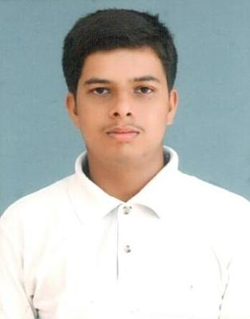

3rd Year B.Tech Student

Computer Science and Engineering

Babu Banarasi Das Northern India Institute of Technology

Contact no. : +917706888991 Email id: srajan.asthana96@gmail.com

**Objective:**

To enhance my practical skills in Computer Science and Engineering, allowing me to utilize my education by gaining valuable work experience in a team oriented environment and to translate my knowledge and abilities into value for an organization.

**Academic Details:**

|  |  |  |  |  |
| --- | --- | --- | --- | --- |
| **Degree** | **Institute** | **Board/University** | **Percentage** | **Year of passing** |
| B.Tech in Computer Science and Engineering | Babu Banarasi Das Northern India Institute of Technology | Dr.A.P.J.Abdul Kalam Technical University | 59% (upto IV Sem) | 2014-Present |
| Class XII(Intermediate) | Lucknow Public College(Lucknow) | ISC | 70 | 2014 |
| Class X(High-school) | St. Paul’s College(Lucknow) | ICSE | 72 | 2012 |

**Technical Skills:**

* **Programming Language:** C, Java, Python
* **Framework: .**NET
* **Scripting Language:** HTML, Javascript, Shell Scripting, Unix
* **Database Management** using MySQL

**Certificates and Achievements:**

* Summer training in Asp.NET with C# from Hwelett Packard Enterprise Education Services
* Advanced Diploma in networking (pursuing)
* Green Technology on plants Workshop
* PHP

**Extra-curricular Activities:**

* Racing, Cricket and Football
* Volunteered in International Badminton Tournament 2012

**Areas of interest:**

* Software Development
* Database Management

**Strengths:**

* Optimistic
* Reliable
* Diligent
* Focus on my goals
* Flexible and adaptable

**Hobbies:**

* Reading
* Football
* Cricket

**Personal Details:**

* **Father’s Name:** Praveen Asthana
* **D.O.B:** 23/08/1996
* **Marital Status:** Single
* **Languages Known:** English and Hindi
* **Permanent Address:** C-374, Rajajipuram, Lucknow-226017
* **Home phone:** 0522-2419091
* **Mobile no.:** 7706888991,8756260261

**Declaration:**I hereby declare that the details furnished above are correct to the best of my knowledge.

**(Srajan Asthana)**

**Date: 24/03/2017**